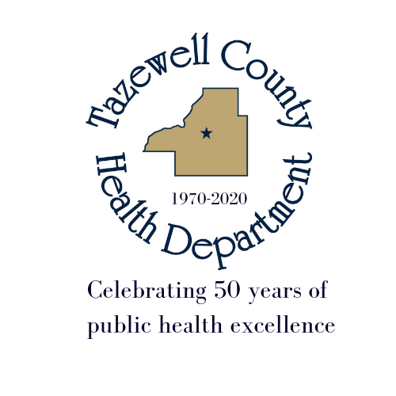

Media Release

Date: June 23, 2021

To: All Media

From: Tazewell County Health Department
Sara Sparkman

For Immediate Release

TCHD COVID VACCINE & TESTING
CHANGES ANNOUNCED

COVID-19 testing at 1800 Broadway in Pekin endS on July 1st. Testing sites continue to be available throughout the community, including hospitals, Heartland Health Services, pharmacies and physicians offices.

Beginning July 14, 2021, TCHD’s COVID vaccine walk-in clinic will operate in Tremont at 21306 IL Route 9. All vaccines will be offered 11:00 am – 4:30 pm each Wednesday. Pfizer is a 2-dose vaccine and is available to persons 12 years or older. Moderna is 2-dose vaccine available to 18 years and older. Johnson & Johnson is a 1-dose vaccine available to persons 18 years and older.

Vaccines are the best way to prevent the spread of COVID-19.

NO APPOINTMENT REQUIRED.

WHAT YOU NEED TO KNOW
- You must bring a valid state ID and provide a phone number.
- Please make sure to wear appropriate clothing to receive a vaccine.
- If you have questions about the vaccine, please reach out to your medical provider prior to scheduling your appointment.
- Receive your COVID vaccination at least 90 days after receiving any monoclonal antibodies (BAM IV infusion) or convalescent plasma as part of treatment for COVID-19.
TCHD Broadway COVID vaccine clinic is open Tuesday & Thursday from 8:30 – 6 until July 8th.
For more information on public health issues, visit http://www.tazewellhealth.org

# # #

