South Pekin Grade School District 137
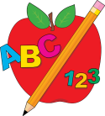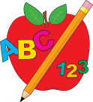
Pre-School for All and ECE Fall Screening

Pre-School for All
Pre-School for All is a blended pre-k classroom. If your child will be 3 years of age on or before September 1st we would love to see him /her at our pre-school screening.

ECE Screening
- Is your child between the ages of 2 years-9 months and 5 years of ages (not yet enrolled in kindergarten)?
- Is your child meeting developmental and academic milestones?
- Are you concerned with how well your child can talk, or how well other people can understand your child?

Where: South Pekin Grade School
When: Wednesday, August 22nd, 2018
Who: Preschool for All (Residents of South Pekin Only)
ECE Program (Residents of South Pekin, Spring Lake, and Rankin School Districts)

Call Mrs. Kennedy at 309-348-3695 to schedule an
appointment to have your child screened.
It is never too early to make sure your child will be ready for Kindergarten.

