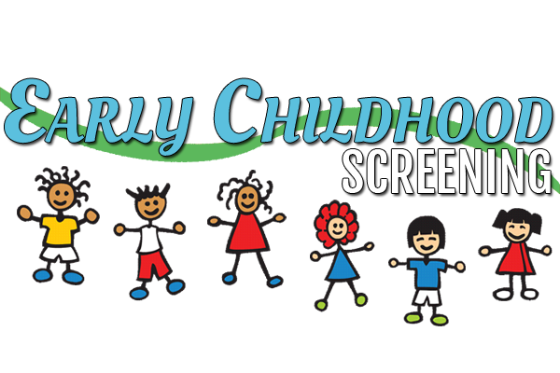

- Is your child between the ages of 2 years-9 months and 5 years
(not yet enrolled in kindergarten)?
- Is your child meeting developmental and academic milestones?
- Are you concerned with how well your child can talk, or how
well other people can understand your child?
ECE Screening
Where: South Pekin Grade School
When: Wednesday, August 23rd, 2017
Who: Residents of South Pekin, Spring Lake and Rankin School Districts
Call Mrs. Kennedy at (309)348-3695 to schedule an appointment to have your child screened. It is never too early to make sure your child will be ready for Kindergarten.
If your child is 4 years of age can he/she:
- Name some colors and shapes
- Count up to 10 objects
- Name about 10 letters
- Remember 3-4 things from a story
- Sustain attention for preferred activities
- Do 8-12 piece puzzles
- Plays with miniatures in dramatic play such as doll houses or garages
- Developing sense of shame/guilt
- Play cooperatively with friends
- Knows opposites
- Answers how & when questions
- Uses 5-4 word sentences
If your child is 3 years of age can he/she:
- Give his/her first name, age & gender
- So simple form puzzles
- Count 1-10
- Remembers finger plays & sings simple songs
- Tries to figure out how things work
- Shows affection or anger
- Shows effort to control emotions
- Talks about things he/she can do
- Understands concepts like “in, out, on, off, under”
- Uses “I”
- About 75% of words can be understood by others

